
Some Guidance for Protesters

Do you have limited experience protesting?
Want some guidance? Here it is!
I was going to set up a meeting*, but then decided it could just be a dense PowerPoint and blog post.
*/ There is a community meeting here in Springfield on March 16 to help the community prepare for the No Kings protest on March 28. https://www.CommunityTogether417.com/events
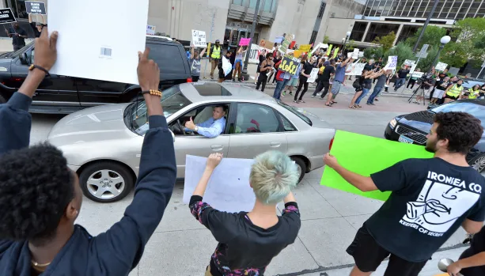
The full text (and this PDF) are available at MarkWelchBlog.com, with some clickable links. I am also narrating a video with the same series of slides.

I'm Mark Welch, a US citizen and a homeowner in the northeast corner of Springfield, Missouri.
I trained and worked as a journalist, before going to law school and becoming a practicing attorney in California. When the internet exploded, I was drawn to consult for internet startups. Later I worked briefly as a secondary teacher, then had a well-paid job selling internet bandwidth at data centers. And then I got sick, and my wife saved my life, and now I'm disabled but angry at America's descent into fascism.
This is not legal advice.
These are my opinions, period.

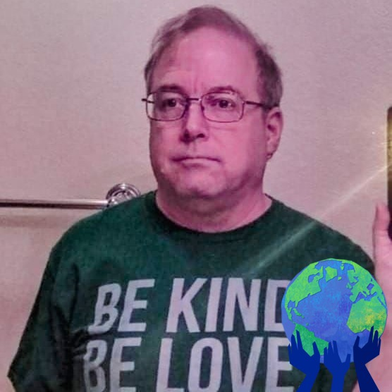

How we got here:
After the 2024 inauguration, I wanted to speak out, to express my concerns about the absurd violations of our Constitution by the current federal administration, led by 47 and his MAGA cultists. I'm not alone.
We're not alone.
I won't go into details, because 47's team is "flooding the zone" with a deluge of illegal orders and violations, across all agencies of our federal government. The MAGA cultists are also extorting education institutions, law firms, medical providers, government contractors, and states as well.

No Kings:
The last two No Kings protests included more Americans than any other protest, ever, in the USA.
I expect that the No Kings protests on March 28, 2026 will break those records.
I expect at least 10,000 people to protest here in the city of Springfield, whose population is 170,000, in a metro area of nearly half a million people.

Talking to my Neighbors:
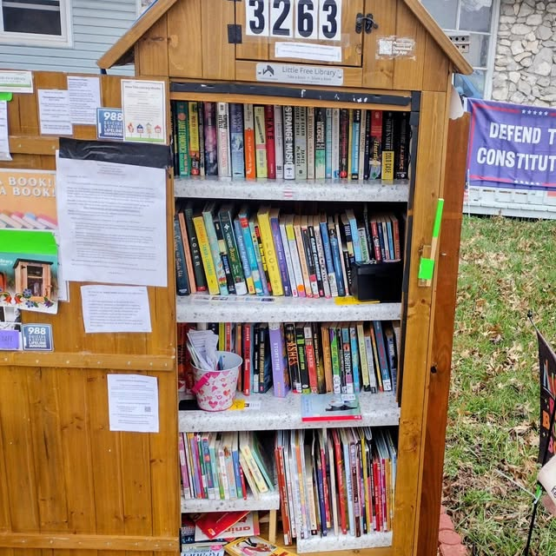
But when I talk to my neighbors, many aren't sure what's going on, nor how they can respond. Some are afraid to speak out.
Late last summer, after we added a Little Free Library in our yard, I walked around our subdivision and knocked on dozens of doors, meeting many neighbors for the first time.
I shared three specific messages:
1st Please visit & use our book-sharing box;
2nd If you use Facebook, please join our neighborhood group;
3rd "The World is on Fire" (not just climate change, but "everything").

I had some insightful conversations with those neighbors, and I've also chatted with many folks around the community, and at more than a dozen protests during 2025.

Effectiveness:
I expect you're asking,
- "What happens at these protests?"
- "How can I effectively share my concerns?"

"Effectiveness" is important to me, as a citizen and as former journalist, lawyer, and teacher. The strategies that worked for me in the past don't feel effective today.
My Missouri Congressmen are MAGA cultists, who ignore most communications from non-campaign-donors. (Burlison, Hawley, Schmidt) I suspect their staffs are not even keeping tally sheets to show how constituents feel.

(I'll talk more about safety later.)

Effectiveness (continued):

But last year, I changed my mindset.
I protest to show my neighbors that I care, and that I believe they should care, too. That's it.
"We care. Join us."
This video is intended to explain to "newbies," who haven't participated in the recent protests, "what's going on."
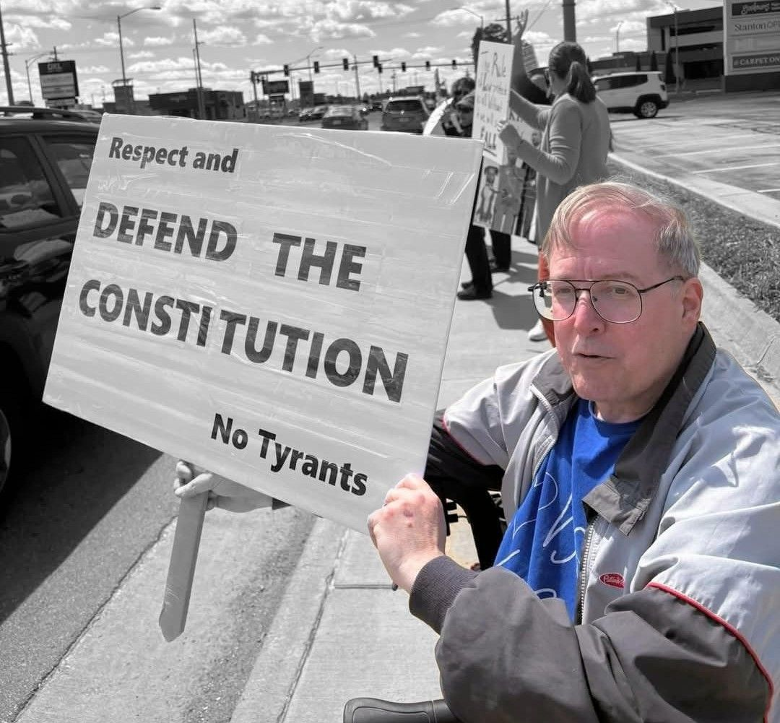

Safety First:
Everyone
is responsible for safety!
Safety is #1.
De-escalate.
Be Love.
(More on this topic later.)

A starting point:
What are your motives and goals?
- Why are you protesting?
- Who is your audience?
- What is your message?
- What is your goal?
- What action or reaction will you seek?

Remember that we are not protesting with any expectation that MAGA cultists will respect us.
Some of them just claim that we are just lazy, unemployed, socialist agitators being paid by George Soros or the global Antifa conspiracy.
(They know that's not true.)

This is our Protest Zone:
The main No Kings protest on Saturday, March 28 in Springfield, Missouri will be along the sidewalks on Battlefield Road: from the Battlefield Mall at Glenstone, then west for two miles, through the Fremont, National, Kimbrough, Jefferson, and Campbell intersections.
https://www.google.com/maps/search/battlefield+mall/
We don't plan to "shut down" this busy corridor in our city, because we want our neighbors to see us and join us.

Map
No Kings – March 28, 2026 – Springfield MO Protest Zone (Battlefield Rd.)
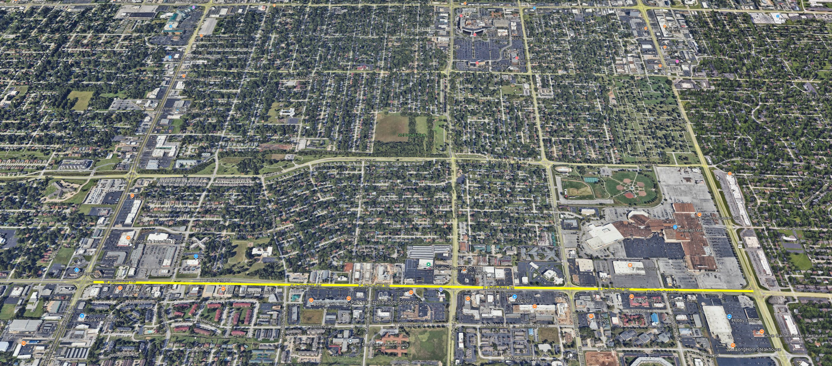
Campbell ← Jefferson ← Kimbrough ← Maryland ← National ← Fremont ← Glenstone

Signs:
Signs are important, especially when there are so many different things to protest.
I suggest that your sign should be big and simple. Focus on three to five key words.
I protest with a very simple sign: "Protect and Defend the Constitution – No Tyrants."

Signs (continued):
Some types of signs are great in a huge crowd of protesters in a downtown square, or on streets that are closed, but are simply not effective messaging for sidewalk protests.
If you have no sign, or if your sign can't be read by the occupants of a car passing by at 30 miles an hour, then those drivers and passengers will make assumptions, based on their pre-conceptions or the more legible signs around you.
Don't add complex graphics, art, or bullet points that can't quickly be understood by that driver passing by at 30 miles per hour.
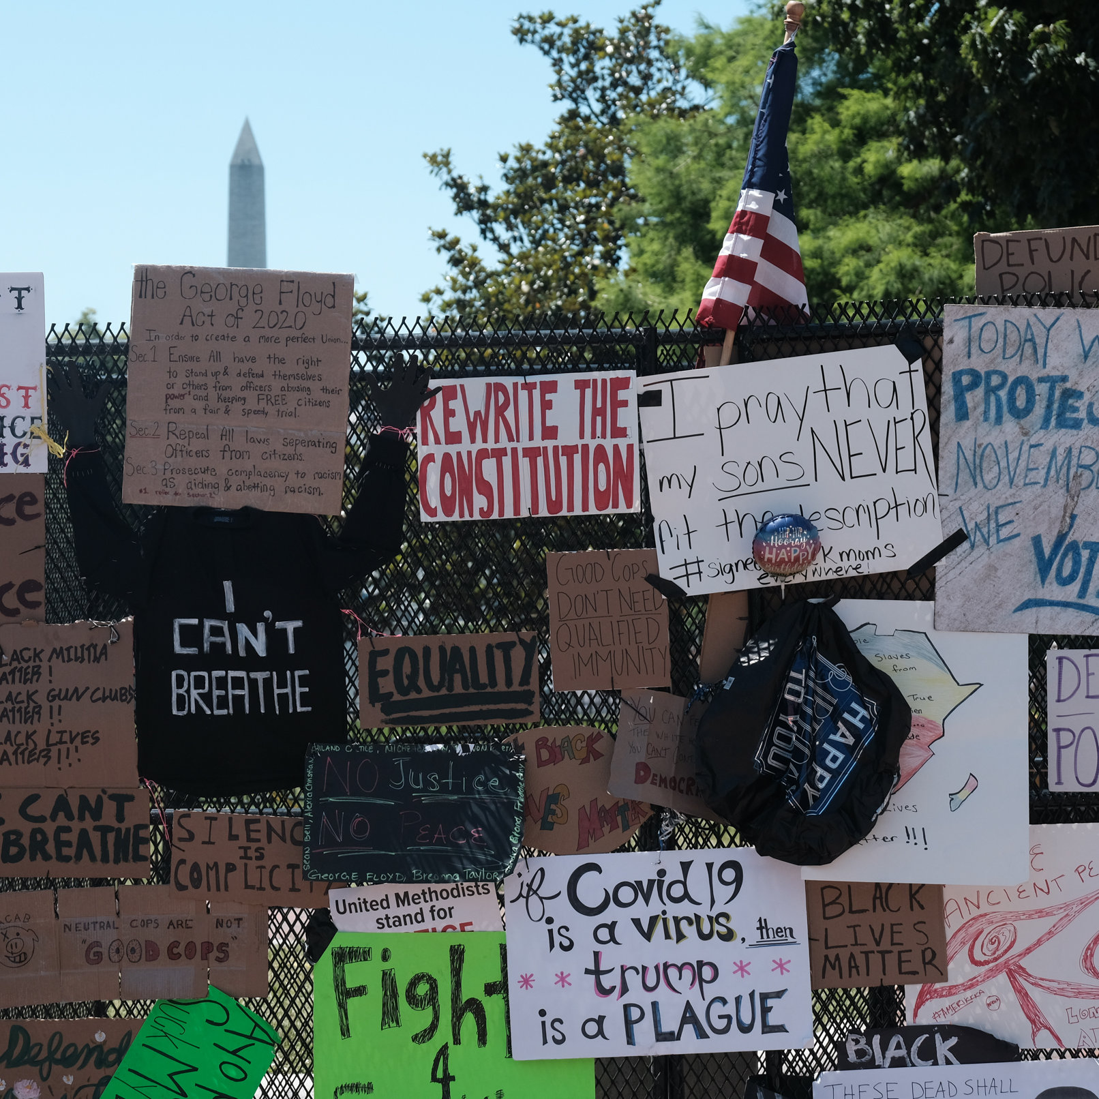
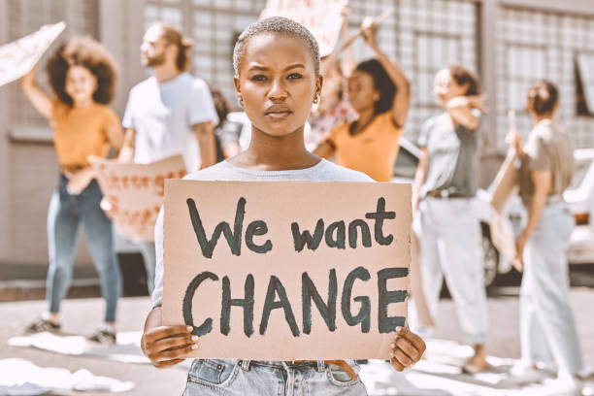

Signs (continued)
No specific signs are prohibited, but some specific signs may “trigger” or create discomfort among other protesters, and may even provoke aggressive responses. (For example, depictions of a swastika, an upside-down US flag, or curse words.)
Be courteous and kind.
Participants certainly can choose not to be near such signs. ("Just walk on" is a phrase you may hear often at a protest, along with "Step Back," to reduce conflict and de-escalate tension.)

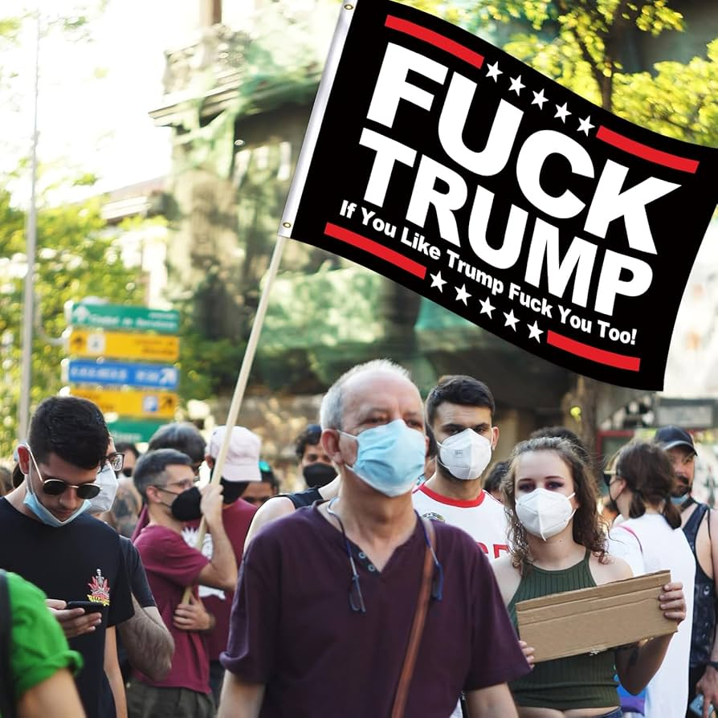
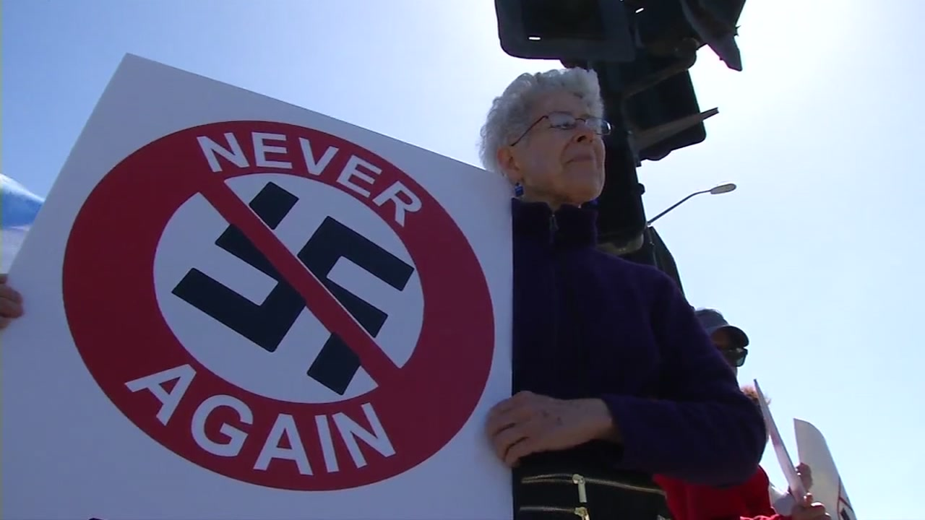
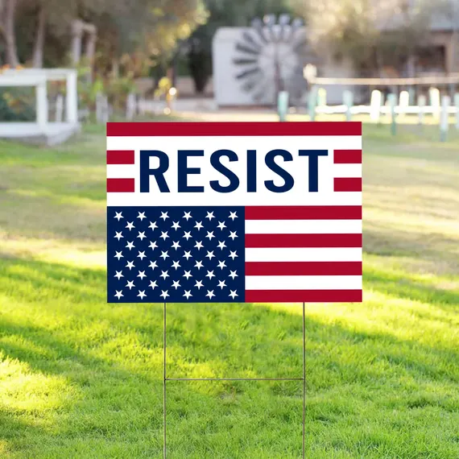

Engagement:
I seek eye contact with passing cars' occupants.
I will generally smile and wave at each car. I give a "thumbs up" to at least one car in each cluster that passes.
Many people respond with a thumbs-up or a wave, and some honk their horns in support. Their smiles are my greatest reward.
Some drivers act as if they're wearing blinders. Maybe they're having a bad day.
(Of course, occasionally, a solo driver will present a middle finger; and I smile and wave in response.)

Planning Ahead:
Please plan ahead before joining a protest.
It's important to understand that in grassroots protesting, and even in huge events like "No Kings," nobody is in charge. The organizers or safety team members are just community members like you, who have no special authority. But please listen to them, because we need all our communities to work together to effectively drive change.
Be love.
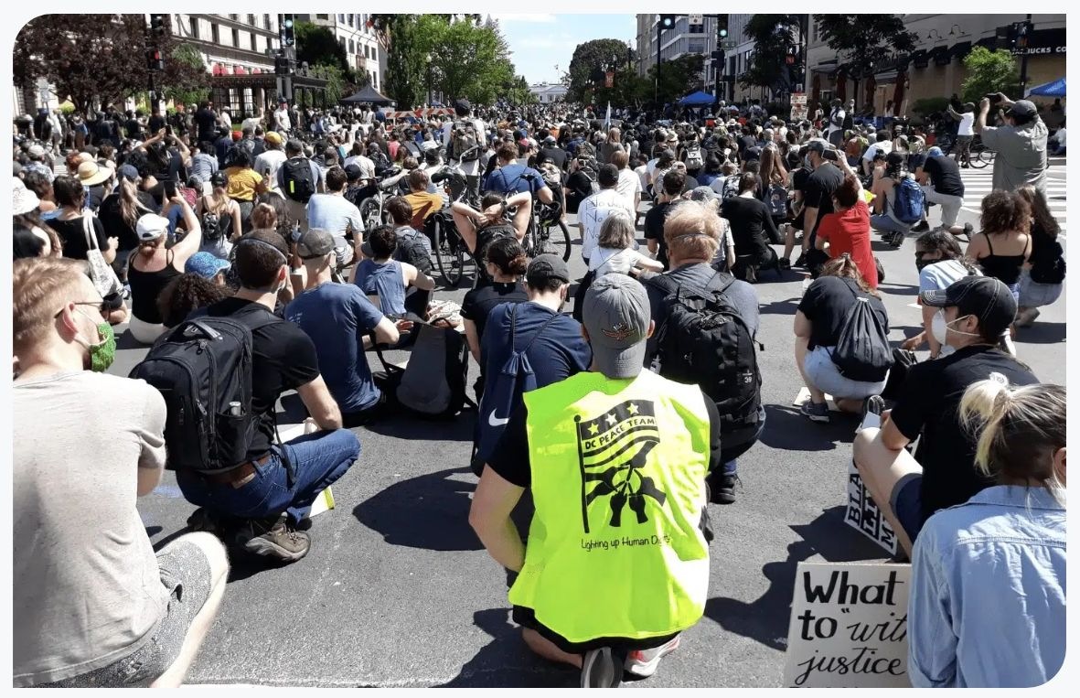

Logistics: Transportation and Parking:
If you'll use public transit, where will that drop you off and pick you up? Consider whether the transit agency might alter its routes or schedules during the protest?
If you'll drive, where will you park?
Please drive to the current "end" of the protest line, park, and spread out!
Please do not obstruct small businesses that are open on Saturday!
Park near where you'll stand: protesters should be near their own cars in the event of any incident.
One tip: if you park at a private business that's open, buy something and place your receipt on your dashboard so it's visible through the windshield; or have one of the store's bags visible, even if it's empty. (A few MAGA businesses will seek to tow away protester's cars.)

Logistics (continued):
What will you wear? What supplies will you bring?
If you will use a cell phone to film or take pictures, how will you hold the phone and a sign and a drink? (Stay hydrated!) What will you do if your phone rings while you're using it to film?
If you have a body camera (separate from your cell phone), please wear it and keep recording, from the moment you arrive, until the moment you're safely home.
I prefer to attach my body camera to my walker (to reduce motion), or to the top of my protest sign (for a higher viewing position).

Logistics (continued):
If you are joined by friends and family members, have a plan for if you get separated. Often, while protesting, I can't even hear my cell phone ring, nor feel vibrations for calls or texts. (I'll talk a bit more about phones later.)
Please pay attention: keep out of the street, make way for pedestrians. Identify nearby public restrooms.
If you will bring children to the protest, pay close attention to them.
Look around for members of the "safety team" who have volunteered to help. At events in Springfield, most safety team members wear bright vests, and will have walkie-talkies to communicate across most of the protest zone. They can also direct folks to first-aid and water, and alert you to potential issues with specific parking or other concerns.

Spread out:
I urge participants with signs to stay more than “arm’s length” distance from each other. Think about what a driver can see!
Participants should not “cluster or clump,” but spread out, to make it clearer to passers-by that the protest is big.
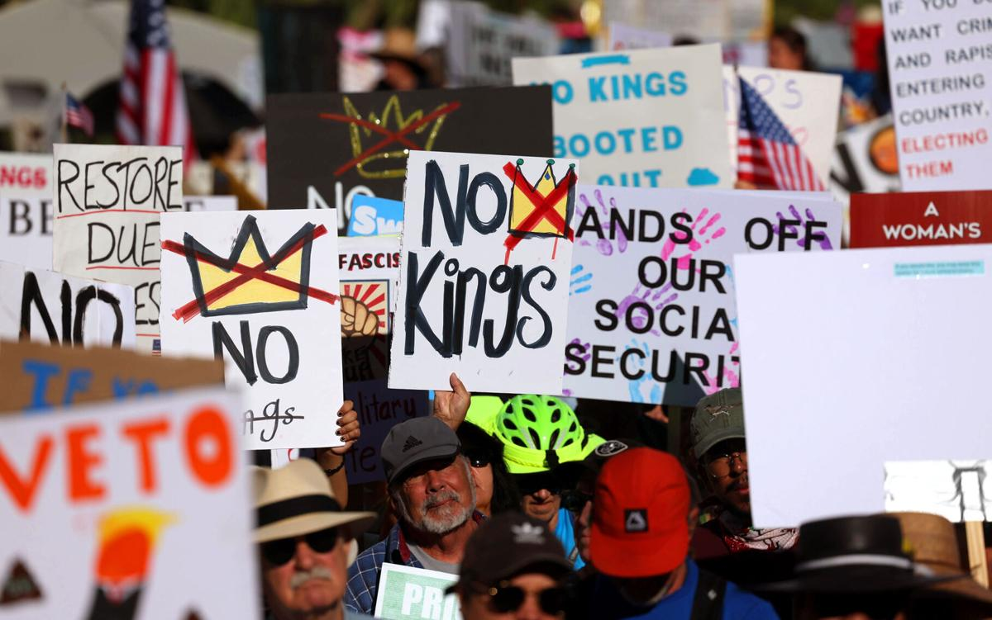

Marching or obstructing traffic:
No!
One main purpose of the No Kings protests is to present our concern to fellow community members: "We Care, and they should, too."
That purpose is not helped by obstruction of traffic. That would just anger drivers, while also redirecting traffic away from our messages.
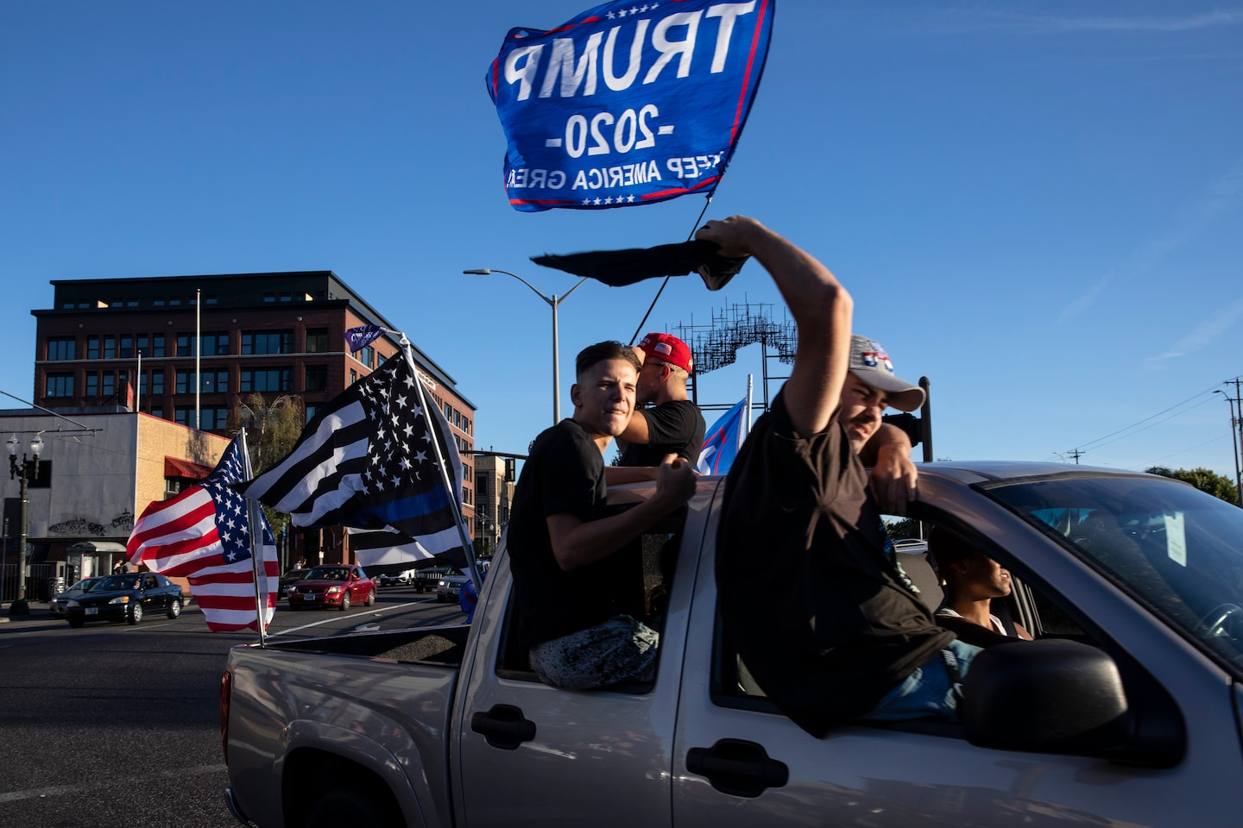
Thankfully, our Springfield protests, including the previous No Kings protests, have been very peaceful, with only minor disruptions by MAGA people seeking to create confrontation and reaction. (At most protests, one or two pickup trucks with MAGA flags will roar by, with occupants shouting and gesturing.)

Phones and Cameras:
You will absolutely be captured on cameras if you attend any protest. (And in all public areas everywhere, all the time.) You may choose to wear a mask, but this may trigger some other participants and passers-by.
Be aware that many business and residential properties in the protest area have their own cameras. The City of Springfield and Missouri DOT also have cameras monitoring many intersections.
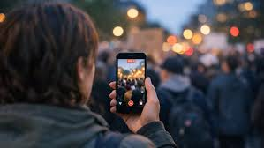
( https://www.ozarkstraffic.com/cameras/ )

Phones and Cameras (continued)
Even if you think your camera caught nothing important, please don't delete the video too soon after the event. You may not be immediately aware of an incident that might have been captured.
If a "genuine" safety incident occurs, then having more camera footage is almost always better.
Note: Along public streets, cameras will inevitably record low-priority violations, such as drivers using cell phones, vehicles with obscured or no license plates, illegally excessive window-tinting, and so on.

Law Enforcement:
After seeing the horrific videos from ICE abuses in Minneapolis, we're all terrified of possible abuses by ICE or law enforcement. (No, ICE officers are not general law enforcement officers.)
We should be afraid of masked thugs with body armor carrying assault rifles, whether or not they claim to be ICE or law enforcement agents.
If your skin is dark, or if you speak Spanish, or if you protest, you should be even more afraid, especially of federal thugs with poor training who believe they are above the law.

Law Enforcement (continued):
My experience with Springfield Police and Greene County sheriff's deputies at our protests have consistently been positive.
SPD doesn't answer their non-emergency number on weekends; use 911.
However, Greene County Sheriff Arnott has been hostile and aggressive toward peaceful, public protesters at our congressmen's offices. And he's been sued dozens of times recently, because his jail holds more than 250 ICE detainees who have no criminal charges, with no legal basis for denying them due process.
And there is ICE activity in Springfield. You should absolutely be concerned about their unchecked violence and disregard for the Constitution.

Law Enforcement (continued):
I am privileged. I am a 65-year-old white male. I was trained as a journalist, as a lawyer, and as a secondary teacher. I worked as a security guard 40 years ago.
At most smaller protests, most of the folks attending have gray or white hair, and we understand that we are privileged to be able to speak out in public (so far).
We don't see nearly as many black or Hispanic neighbors at our protests, compared to the proportion they exist in our city.
We understand why they're reluctant, and we are angry at the federal administration for deliberately driving their fears.

Some Precautions to Consider:
Lock your phones with a PIN.
If you normally use your face or thumb or fingerprint or a pattern/swipe to unlock your phone, disable those features. Ideally, your PIN should be longer than 4 characters.
You may consider leaving your phone at home or in your car, turning your phone completely off, switching to airplane mode, or using a bag that blocks radio frequency (RFID) signals.
If you have a body camera, you might want to bring multiple SD cards, prepared to swap cards after any significant incident.
If you can do so, stream your video footage to "the cloud."

Law Enforcement (continued):
If law enforcement requests that you stop recording: you should first repeat their command and ask them to confirm, so this illegal command is clearly recorded on your device.
You could say, "I have the legal right to record activity in public," and continue recording.
But maybe not? Some protesters in Minnesota and elsewhere have had their devices illegally confiscated or destroyed by ICE agents. And much worse stuff can happen if you challenge certain folks.
You'll use your best judgment, and you won't try to provoke folks in uniform.
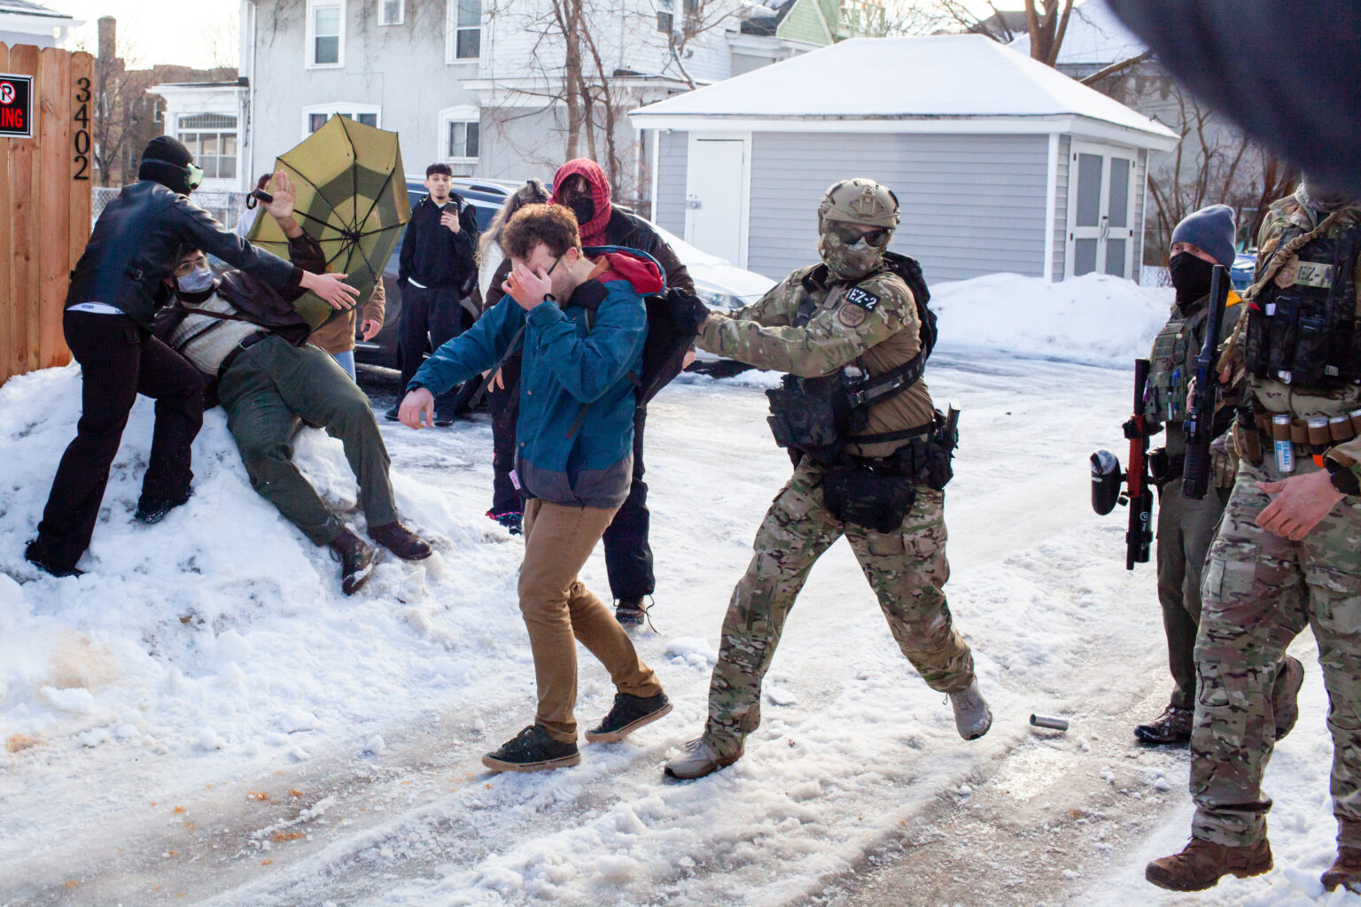

Law Enforcement (continued):
If any law enforcement officer or ICE agent contacts you, you should immediately ask,
"Am I being detained?"
If the answer is yes, then shut the freak up!
If the answer is no, then say, "I do not wish to talk with you."
Again, I am privileged as an older white man with legal experience, so I sometimes engage with police and assist them in understanding the situation "on the ground" at protests.

Law Enforcement (continued):
If law enforcement requests to access your phone or camera, demand a judicial warrant and get legal advice. Say, "I do not consent to a search of my person or my property."
(If law enforcement demanded that I hand over my phone or camera, I'd demand a supervisor be called to the site, and I'd insist that my device(s) be immediately placed into a sealed evidence bag, with any attempted search deferred until a ruling by a judge.)

Finally, I'll repeat:
It's important to understand that in grassroots protesting, and even in huge events like "No Kings," nobody is in charge. Any sponsors or organizers are just community members like you, who have no special authority.
But listen to them, because we need all our communities to work together to effectively drive change.

Be Love.



Springfield Organizations Fighting for Your Rights

CommunityTogether417.com
Greater Springfield Indivisible
50501
SMIA
Stop Project 2025

Table of Contents
Some Guidance for Protesters 1
How we got here: 2
No Kings: 3
Talking to my Neighbors: 4
Effectiveness: 5
Effectiveness (continued): 6
Safety First: 7
A starting point: 8
This is our Protest Zone: 9
Map 10
10
Signs: 11
Signs (continued): 12
Signs (continued) 13
Engagement: 14
Planning Ahead: 15
Logistics: Transportation and Parking: 16
Logistics (continued): 17
Logistics (continued): 18
Spread out: 19
Marching or obstructing traffic: 20
Phones and Cameras: 21
Phones and Cameras (continued) 22
Law Enforcement: 23
Law Enforcement (continued): 24
Law Enforcement (continued): 25
Some Precautions to Consider: 26
Law Enforcement (continued): 27
Law Enforcement (continued): 28
Law Enforcement (continued): 29
Finally, I'll repeat: 30

